Nasa Spectroscopy Lab Data Sheet Name:

1. Incandescent Bulb

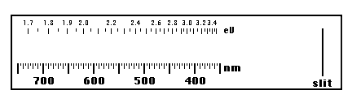

2. Hydrogen Gas Tube



3. Helium Gas Tube



**4. Neon Gas Tube**



5. Mercury Gas Tube



6. Grow Light Bulb



7. Chemical Light Stick



### Questions to Answer

1. Helium was discovered in the Sun's corona during the eclipse of 1868. In 1888, traces of helium were isolated here on Earth. How could scientists determine that this was the same gas that had been identified on the Sun?
2. Compare the results of the various gas tube spectra with the spectrum observed using the standard fluorescent light tube. Based on your results, what gas do you think is used in fluorescent light tubes?
3. What colors dominated the spectrum of the "Plant Grow" light? How was this different from the regular light bulb? Can you think of a reason why this light might be better for plants (hint: plants are usually green...)?